**How to Upload the Template**

The template can be imported – first by right clicking on the object below and saving on to your desktop. To upload into Emis you need to have access to template manager in configurations on the home button. If you do not then please ask you practice manager for access or to upload the template for you

**The Template:**



**Notes on Template**

* The template is a tool for you to complete your structured medication review.
* It can also be used for other medication reviews or medication queries.
* Complete only the parts of the template that you need too
* Resource links are available in the template.
* It would be a good idea to become familiar with the template and resources before you do a review
* **Don’t forget to tick the SMR box if the review qualifies for an SMR as per NHS guidance.**

**Page 1**

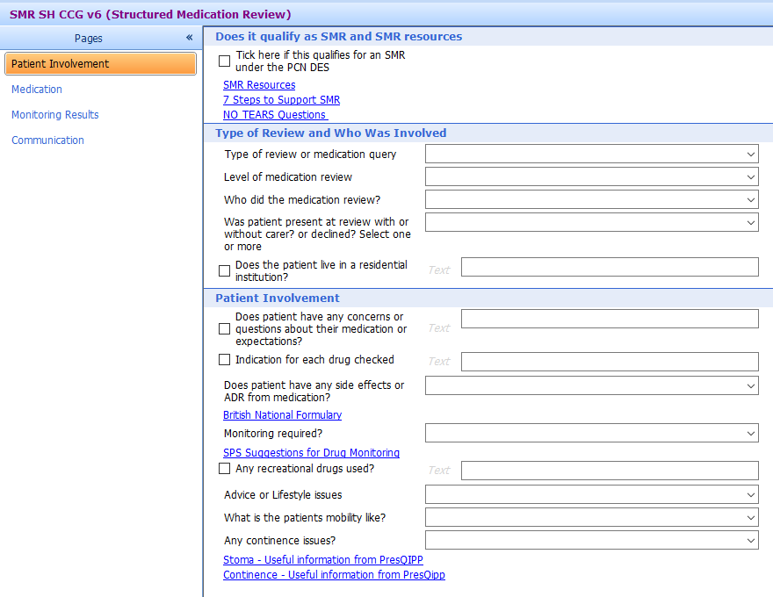

**Page 2**

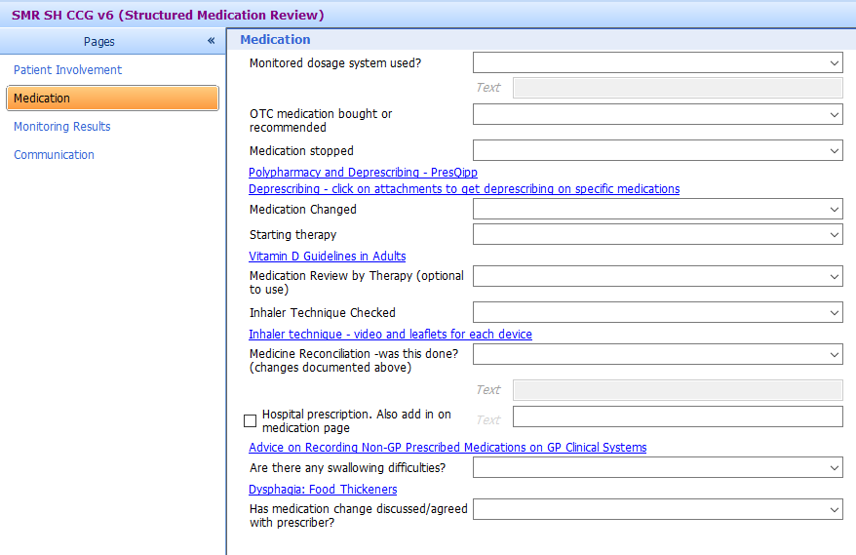

**Page 3**

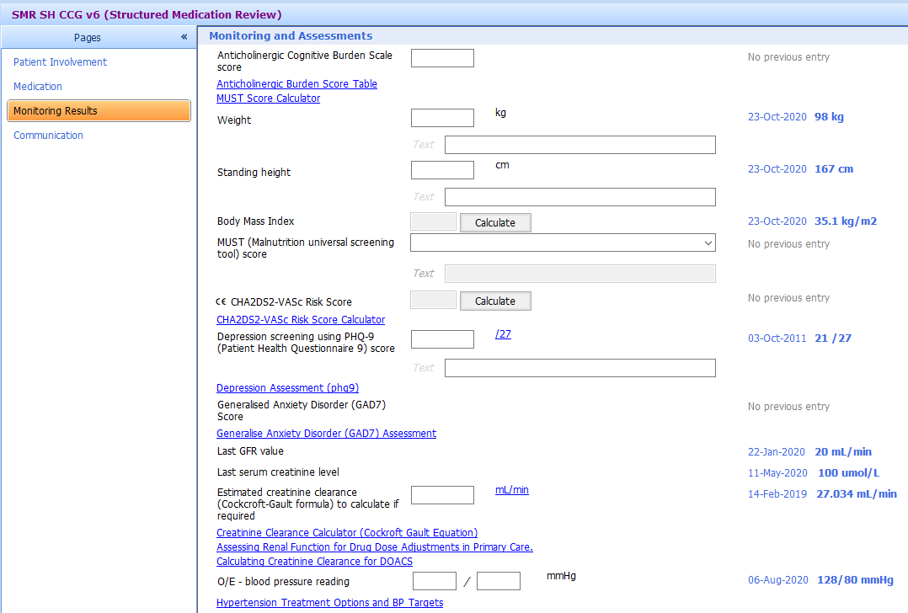

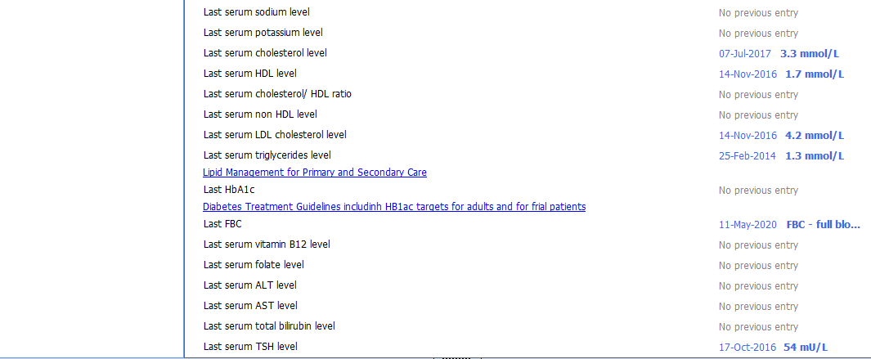

**Page 4**

